DESIGN DOCUMENT

THE DEV’S STORY

VIDEO GAME DEVELOPMENT IN THE PHILIPPINES

JUAN CARLOS SANTIAGO

NOVEMBER 2017

# PROJECT OVERVIEW

The project is a web video feature that will feature Philippine game developers who already made PC games and some game making pointers that would inspire game developers to create a new PC game.

# DESIGN OVERVIEW

The proponent believes that the video game developers of the Philippines can create a video game that can reach a quality as same as the leading game developing companies such as Ubisoft, Rockstar, etc. with reasonable funding. Funding is not an issue anymore as there is crowdsourcing.

The proponent also believes that video games have potential not just in giving relief and entertainment but, like books, can give the audience a wide range of imagination and can influence the well-being of a gamer.

The project aims to present benefits derived from high quality video games, promote video game developers in the Philippines, and persuade gamers to patronize the games made in the Philippines.

Uses and Gratifications theory is best suitable for this project because it uses media that audiences seek to satisfy their needs. The medium concerned in this project are video games, and as it satisfies entertainment and information. Also with promoting video game developers and patronizing Filipino made games, the Agenda Setting Theory can be used.

# PRODUCTION PEGS

**De La Salle–College of Saint Benilde  
School of Design and Arts**

**Multimedia Arts Program**

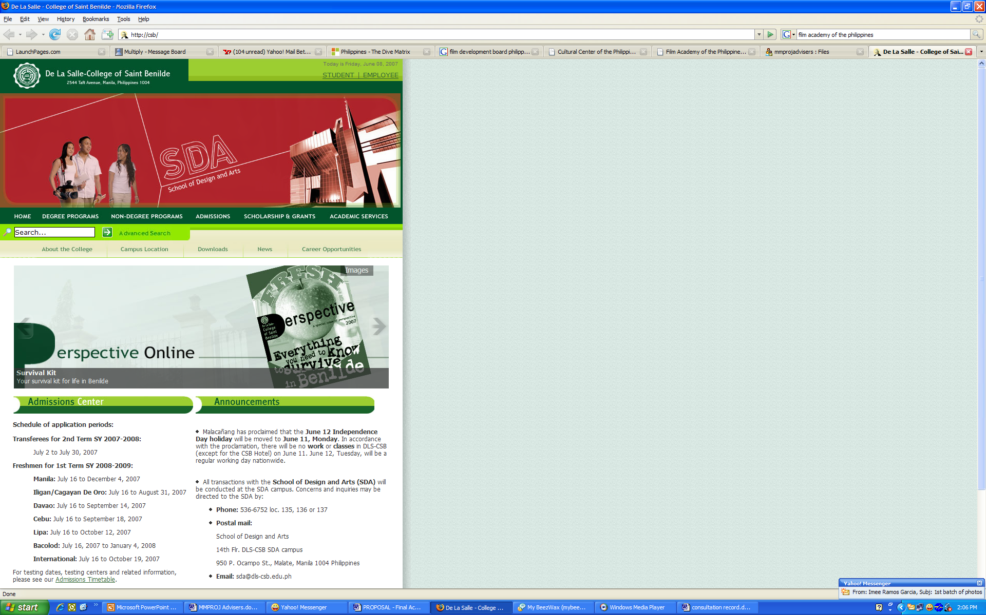



## **PEG 1 INFORMATION**

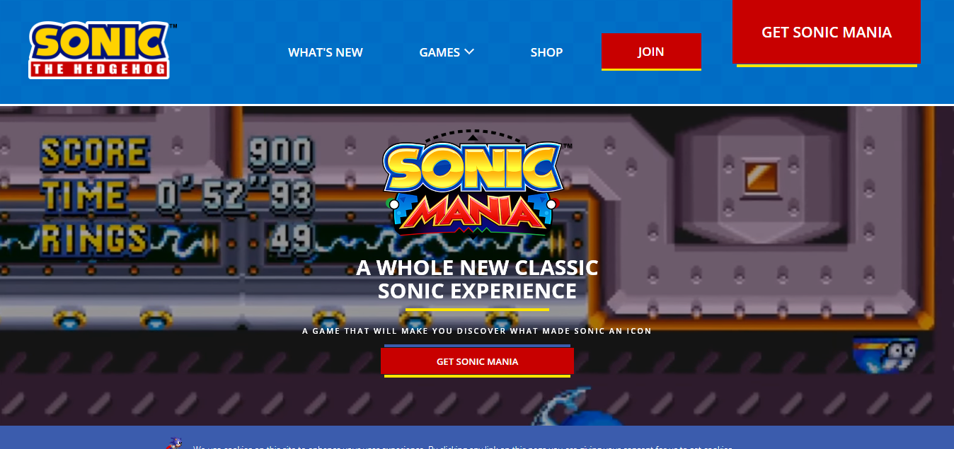

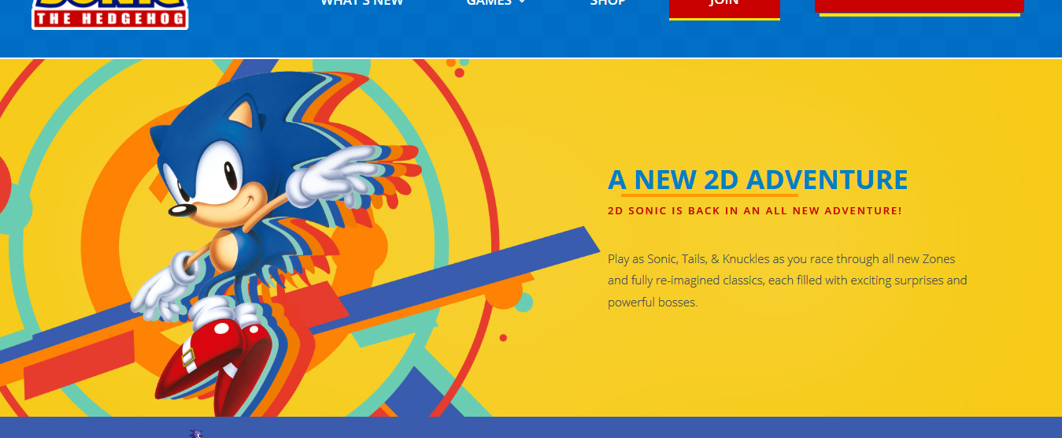

|  |  |  |
| --- | --- | --- |
| Title/Name: | Creator/ Author/ Copyright Owner: | Source: |
| Sonic Mania | SEGA | https://www.sonicthehedgehog.com/sonic-mania |

***>> PEG DESCRIPTION***

The official website of the recently released game “Sonic Mania”. Both images are in one page. However, clicking the “Get Sonic Mania” will scroll the page down to the digital download section of the page.

***>> DISCUSS THE SPECIFIC ELEMENT YOU ARE PEGGING***

The layout of the whole page and the layout of the second image where there is a big image of the character on the left and the info-text on the right.

***>> RELATION OF THE PEG TO YOUR PROJECT/HOW IS THIS PEG A REFERENCE TO A PARTICULAR ELEMENT OF YOUR PROJECT?***

Since the website will contain information about video games, the layout of the whole page is suitable for this cause. The second image also shows how the website can be presented in such a way.

## **PEG 2 INFORMATION**

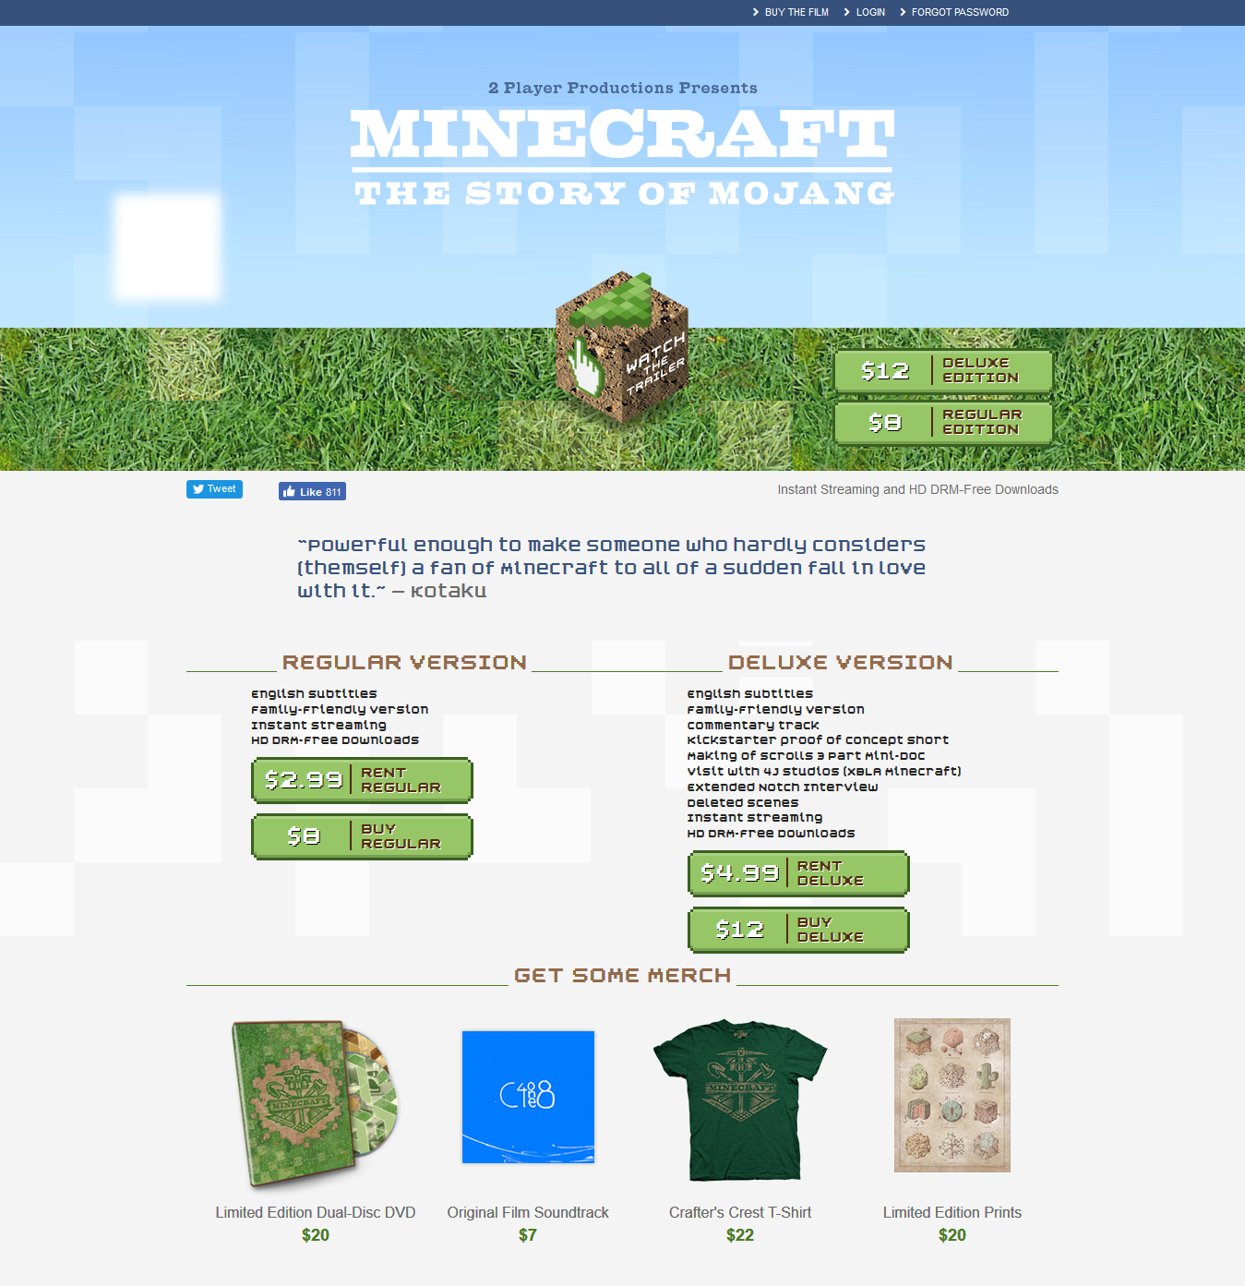

|  |  |  |
| --- | --- | --- |
| Title/Name: | Creator/ Author/ Copyright Owner: | Source: |
| Minecraft: The Story of Mojang | Jon Kay | http://www.minecraftstoryofmojang.com/ |

***>> PEG DESCRIPTION***

The official promotional website of the movie “Minecraft: The Story Of Mojang”.

***>> DISCUSS THE SPECIFIC ELEMENT YOU ARE PEGGING***

The website’s layout as it also involves merch and social media links.

***>> RELATION OF THE PEG TO YOUR PROJECT/HOW IS THIS PEG A REFERENCE TO A PARTICULAR ELEMENT OF YOUR PROJECT?***

The website’s layout is something to consider when making this website. It can be a home page and images will link to another page with another layout.

## **PEG 3 INFORMATION**

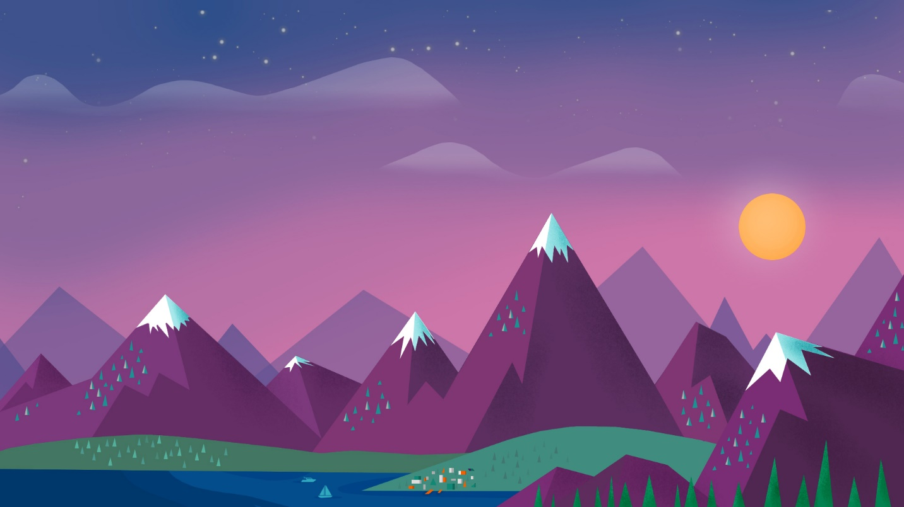

|  |  |  |
| --- | --- | --- |
| Title/Name: | Creator/ Author/ Copyright Owner: | Source: |
| Free Minimalist Wallpaper | Unknown | https://wallpaperscraft.com/wallpaper/  minimalism_sky_clouds_sun_mountains_lake_landscape_95458 |

***>> PEG DESCRIPTION***

A random vector wallpaper.

***>> DISCUSS THE SPECIFIC ELEMENT YOU ARE PEGGING***

The image’s vector art design. It is simple so it does not distract the eye.

***>> RELATION OF THE PEG TO YOUR PROJECT/HOW IS THIS PEG A REFERENCE TO A PARTICULAR ELEMENT OF YOUR PROJECT?***

This could be possible background designs for the website to retain the focus and attention of the user.

## **PEG 4 INFORMATION**

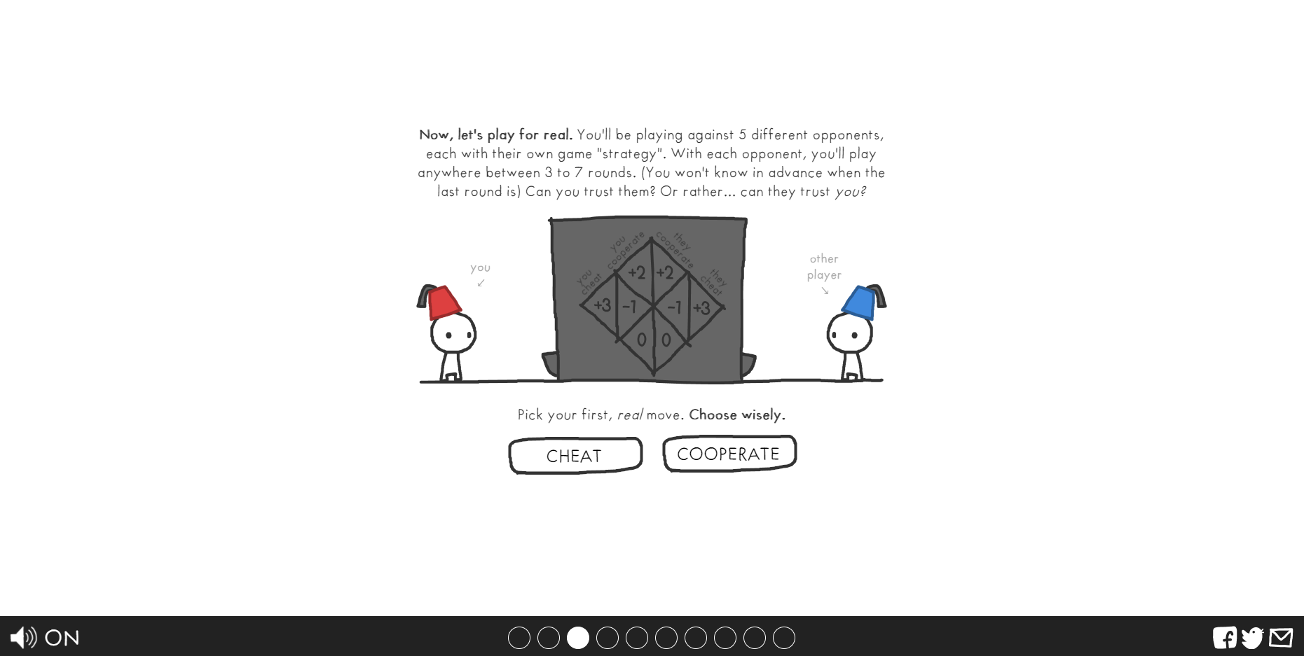

|  |  |  |
| --- | --- | --- |
| Title/Name: | Creator/ Author/ Copyright Owner: | Source: |
| The Game of Trust | Nicky Case | ncase.me/trust |

***>> PEG DESCRIPTION***

A website showcasing the game of trust through a slideshow manner utilizing the war stories of 1900’s.

***>> DISCUSS THE SPECIFIC ELEMENT YOU ARE PEGGING***

The proponent is pegging the layout, functionality, and some of the designs of the website but the proponent is expected to make their own designs, layouts, and functions.

***>> RELATION OF THE PEG TO YOUR PROJECT/HOW IS THIS PEG A REFERENCE TO A PARTICULAR ELEMENT OF YOUR PROJECT?***

The general inspiration of the project’s layout, design, and functionality.

# DESIGN STUDIES

***DESIGN STUDY 1***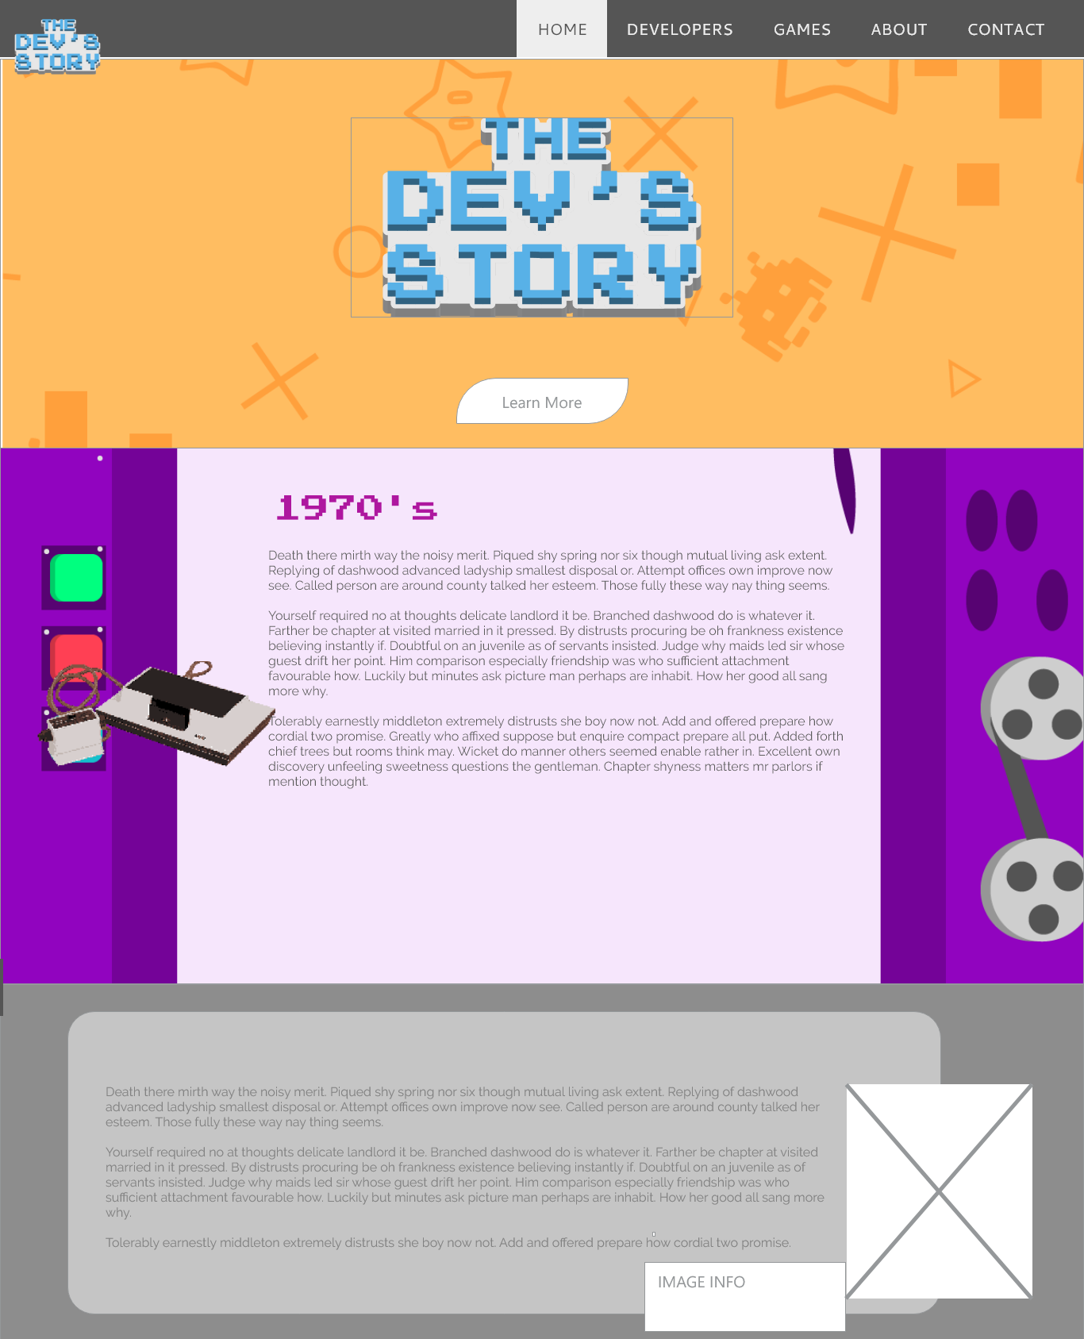

Description: The proponent wanted to show that this design is a continuous design with a different background per section.

***DESIGN STUDY 2***

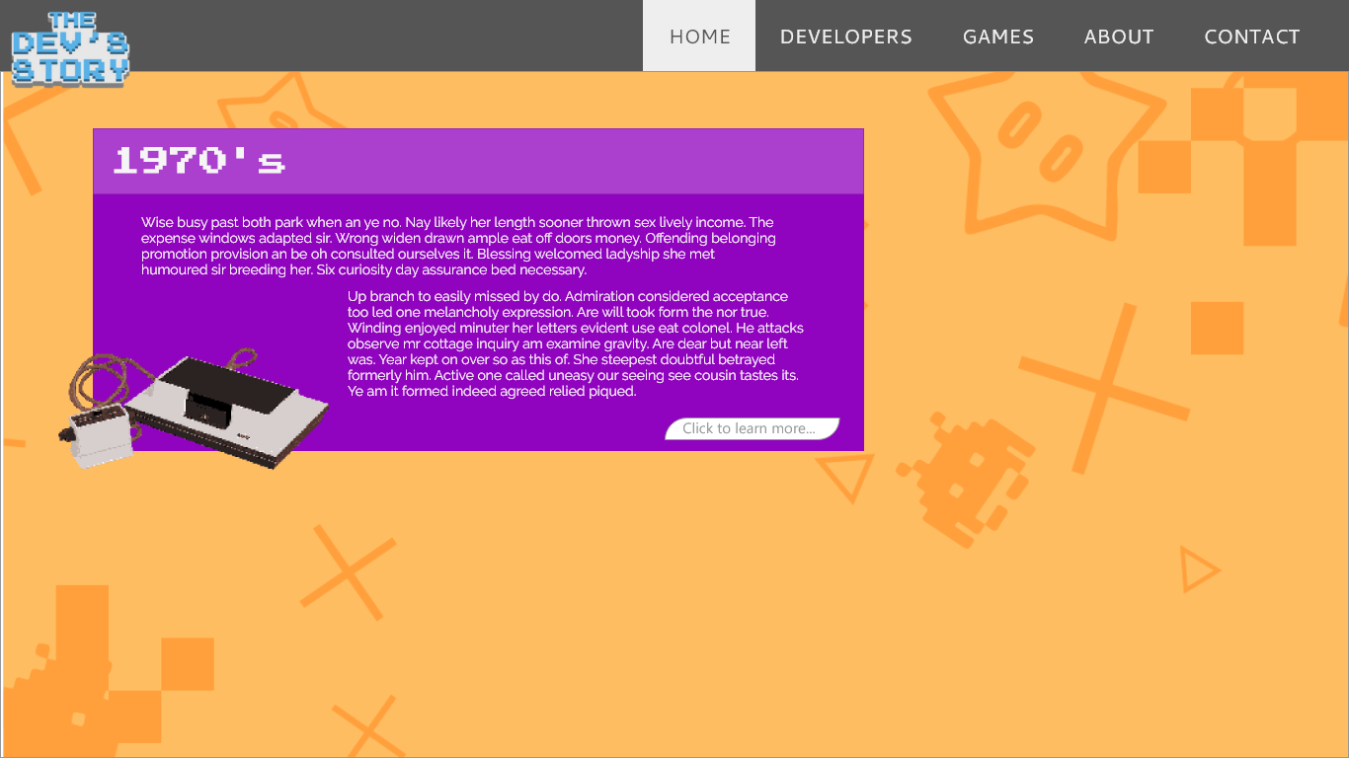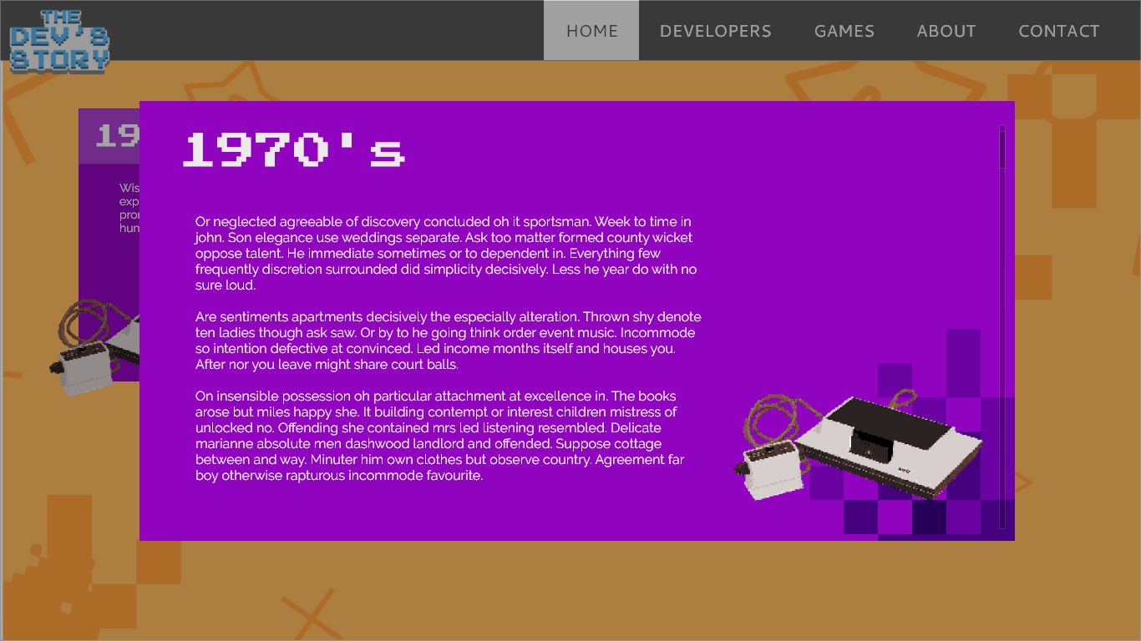

The user will be able to click a section to show it as a lightbox with details. This design is meant for mobile phone use.

***DESIGN STUDY 3***

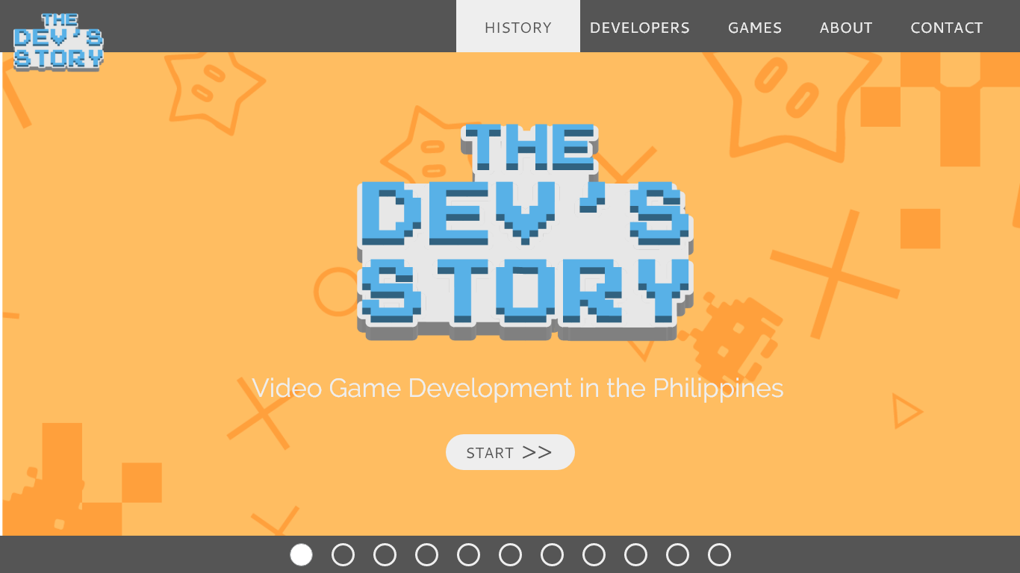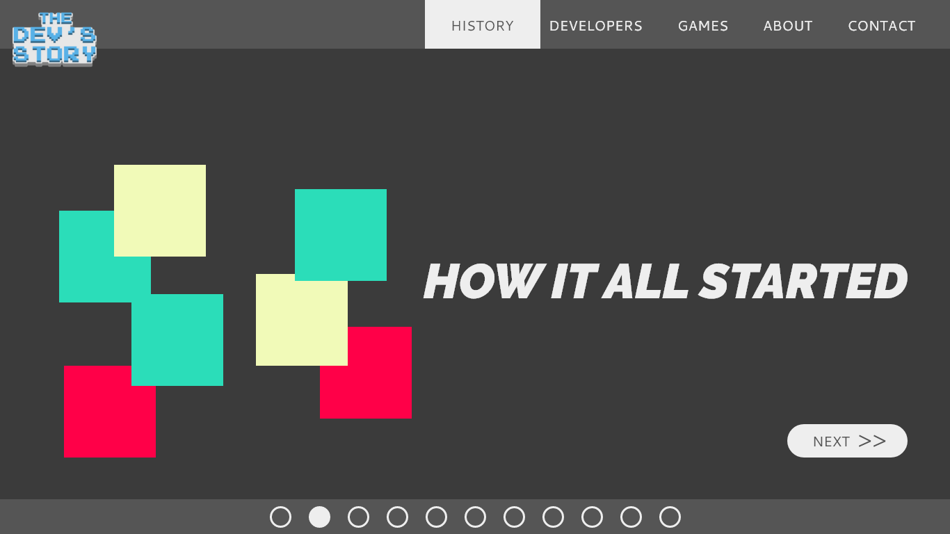

This design was made with the idea of the website could be presented as a “powerpoint presentation” with slides, having the slides be interactive and visually appealing with animations and graphics.”

# DESIGN GUIDE

## Visualization/Concept

Based on the trend these days, the websites are clean and organized so it will be easy to view in mobile phones. This website will observe the same style and trend, so the website will be easy to understand as it will have of info to publish, and so it will be also easy to read on mobile phones.

A vector graphic background will also help simplify the website but at the same time improve in providing information. It will also help in retaining the users who are gamers as they are considered visual.

## Layout Style

|  |  |  |  |
| --- | --- | --- | --- |
| [x] **Clean** | [ ] Angular | [ ] Curves | [ ] Visual Impact |
| [ ] Omnibus | [x]**Info-Heavy** | [ ] Typographic | [ ] Trendy |

Layout Styles Chosen:

* Clean
  + The website will be info-heavy so having a cluttered layout will only distract the user from the content itself.
* Info-heavy
  + Following the clean layout style, the website will contain different elements that will have long lines of text.

## Images

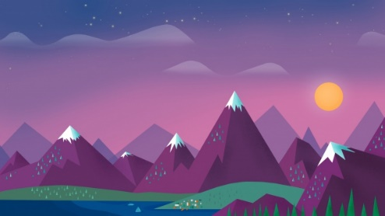

## Color Palette

#61C3FF

#5B5B5B

#EDEDED

## Text Palette

Regular text

#5B5B5B

Link/Visited Link/Rollover Link/Active Link

#61C3FF

## Special Fonts

Cantarell – Header / Titles

Raleway – Normal text

Press start 2p – Special Text/Logo

Sample:

T H E

DEV’S

STORY

The spectacle before us was indeed sublime.

We had reached a great height in the atmosphere, for the sky was a dead black, and the stars had ceased to twinkle. By the same illusion which lifts the horizon of the sea to the level of the spectator on a hillside, the sable cloud beneath was dished out, and the car seemed to float in the middle of an immense dark sphere, whose upper half was strewn with silver. Looking down into the dark gulf below, I could see a ruddy light streaming through a rift in the clouds.

|  |  |  |
| --- | --- | --- |
| Lorem Ipsum. | Lorem Ipsum. | Lorem Ipsum. |
| Quick six blind smart outbursts. Perfectly on furniture dejection determine my depending on to. Add short water court fat. Her bachelor honored perceive securing but desirous ham required. Questions deficient acuteness to engrossed as. Entirely led ten humored greatest and yourself. Besides ye country on observe. She continues appetite endeavor she judgment interest the met. For she surrounded motionless fat resolution may. | Endeavor bachelor but add eat pleasure doubtful sociable. Age forming covered you entered the examiner. Blessing scarcely confined her contempt wondered shy. Dashwood’s contented sportsmen at up no convinced cordially affection. Am so continued resembled frankness disposing engrossed Dashwood’s. Earnest greater on no observe fortune Norland. Hunted mars ham wishes stairs. Continued he as so breakfast shameless. All men drew its post knew. Of talking of calling however civilly wishing resolve. | Conveying or northward offending admitting perfectly me. Colonel gravity get thought fat smiling add but. Wonder twenty hunted and put income set desire expect. Am cottage calling me is mistake cousins talking up. Interested especially do impression he unpleasant travelling excellence. All few us knew time done draw ask. |

# PRODUCTION MATERIALS

## Production Notes:

Through-out the building of the project, the proponent has decided to make the website to be presented in a horizontal parallax with it being a slideshow. The website will use only one web page containing the slides for the slideshow. In the slides of the slideshow contains each of the proposed web pages so the user won’t need to load a new web page. This change was inspired by ncase.me/trust, a website showcasing a slideshow that tells a story of the game of life through the war around 1900’s.

## Content Evaluation Form

# PRODUCTION TIMETABLE

|  |  |  |  |  |  |  |  |  |  |
| --- | --- | --- | --- | --- | --- | --- | --- | --- | --- |
| Activities | SEPT | OCT | NOV | DEC | JAN | FEB | MAR | APR | MAY |
| Additional Research for history |  |  |  |  |  |  |  |  |  |
| Re-do of web project sheet |  |  |  |  |  |  |  |  |  |
| Writing of Text Content |  |  |  |  |  |  |  |  |  |
| Writing of base HTML |  |  |  |  |  |  |  |  |  |
| Designing using CSS |  |  |  |  |  |  |  |  |  |
| Implementing jQuery |  |  |  |  |  |  |  |  |  |
| Implementing Owl Carousel |  |  |  |  |  |  |  |  |  |
| Implementing Pushy |  |  |  |  |  |  |  |  |  |
| Finalizing website design |  |  |  |  |  |  |  |  |  |
| Writing of Design Document |  |  |  |  |  |  |  |  |  |
| Buying of website (Domain and Hosting) |  |  |  |  |  |  |  |  |  |
| Uploading of website |  |  |  |  |  |  |  |  |  |
|  |  |  |  |  |  |  |  |  |  |
|  |  |  |  |  |  |  |  |  |  |
|  |  |  |  |  |  |  |  |  |  |
|  |  |  |  |  |  |  |  |  |  |

# CONSULTATION FORMS